A12 - User Manual

Year: 2023 Semester: Fall Team: 5 Project: Smart Air Hockey Table

Creation Date: November 13, 2023 Last Modified: November 18, 2023

Author: William Dobert Email: wdobert@purdue.edu

1. Product Description

The Smart Air Hockey Table (SAHT) is a sophisticated iteration of the traditional arcade game, integrating advanced technological enhancements in a home entertainment format. The SAHT will amaze time and time again, as it reacts dynamically while you play the game with dazzling lighting effects. As you and your opponent score one goal after another in this fast-paced game, the SAHT keeps track of the game score automatically and intuitively. Being the perfect addition to any home rec room, the SAHT only requires a single power outlet for full-powered fun.

1. Product Illustrations

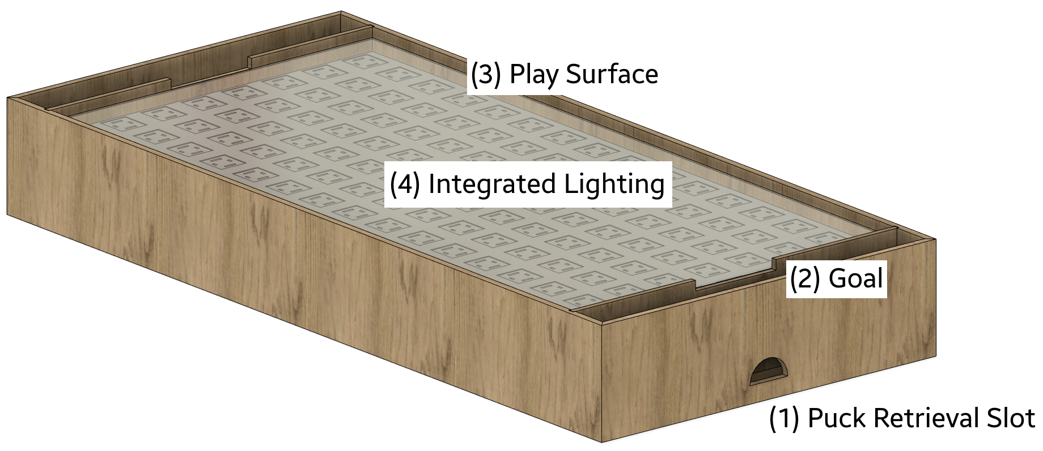

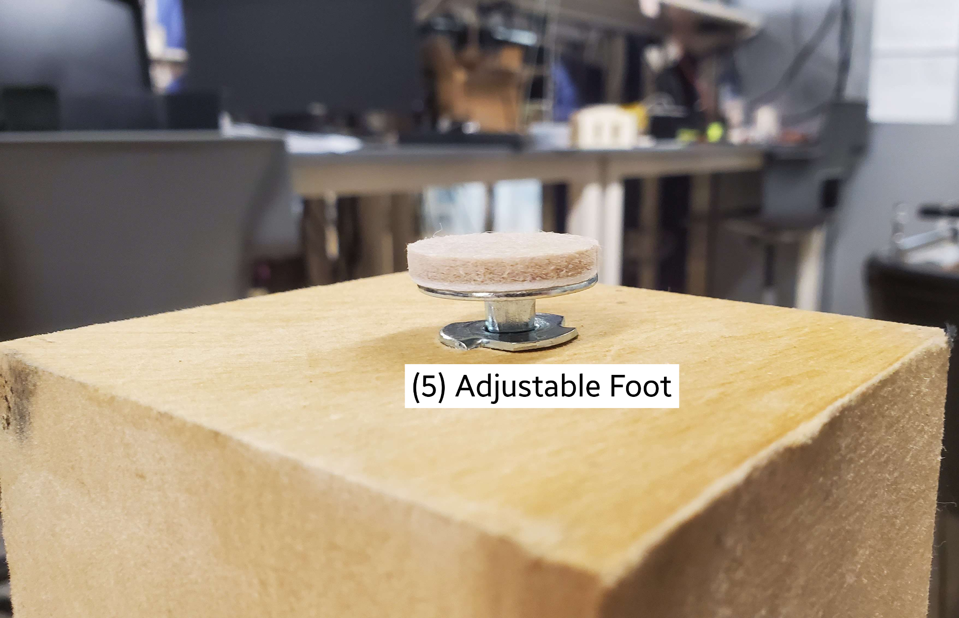

1. Setup Instructions

**Initial Installation**

1. Ensure the SAHT is placed on a level surface with minimal obstructions in the immediate vicinity.
2. Loosen or tighten the integrated *Adjustable Feet* until the SAHT appears level and flat.
3. Plug the included power cable into a nearby outlet.
4. Usage Instructions

**Power-On and Gameplay**

1. Press the activation button located adjacent to the *Goal*.
2. Place the included air hockey puck on the *Play Surface*.
3. Each player stands in front of the opposing *Goals* and holds the included pushers in their dominant hand.
4. Slide the pusher across the *Play Surface* to strike the puck and send it into the opposing *Goal*. The opposing player will attempt to return the puck by striking it with their pusher. Avoid hitting or striking the *Play Surface* with the pushers at all times, as there are fragile components contained immediately beneath.
5. Once a goal has been scored by either player, the puck can be found in the *Puck Retrieval Slot*. Remove it and return to step 2.
6. Once the game has concluded by reaching a player-specified score limit, press the activation button again to power off the SAHT.
7. Troubleshooting Instructions

Lack Of Airflow

In the event that the SAHT does not appear to have adequate airflow emitting from the *Play Surface*, ensure that there are no obstructions on or near the underside of the table. There must also be no objects placed on the *Play Surface* at any time, except for the provided puck and pushers. Additionally, ensure that the SAHT has been properly installed and powered on according to the instructions given above.

**No Lighting Effects Are Visible**

If there is no dynamic lighting effect as the puck is moved across the *Play Surface*, power off the SAHT completely by unplugging the power cable. After waiting for 5 seconds, plug the power cable in again and continue with the power-on instructions listed above.

**Puck Drifting**

If the puck continually drifts in a certain direction without any outside interference, the SAHT has not been properly leveled. Adjust the integrated *Adjustable Feet* until the table is level and puck drifting has been eliminated.

**Additional Concerns**

If a problem has been encountered with the SAHT that is not remedied in this document, please contact [support@saht.com](mailto:support@saht.com) immediately with a detailed description of the issue, or call 1-800-782-5488.